Bibliometric Analysis

First Author¹*, Second Author ², Third Author³

¹ Affiliation of the first author

² Tunku Puteri Intan Safinaz School of Accountancy, Universiti Utara Malaysia 06010 UUM Sintok, Kedah, Malaysia

³Affiliation of the third author

*Corresponding author E-mail: aidi@uum.edu.my

Abstract

Purpose –

Design/methodology/approach –

Findings –

Research limitations/implications –

Originality/value –

Keywords:

- INTRODUCTION

Background….

Problem statements…

Objectives/aims of the paper…

Research Questions…

The rest of this paper is structures as follow… The next section…

- LITERATURE REVIEW

Bibliometric Analysis

Past Studies

- METHODS

Database: Scopus
Search Field: Article Title
Time Frame: All
Language: English
Source Type: Journal
Document Type: Article
TITLE("ecommerce" OR "e-commerce" OR "e commerce" OR "electronic commerce") AND ( LIMIT-TO ( DOCTYPE,"ar" ) ) AND ( LIMIT-TO ( LANGUAGE,"English" ) ) AND ( LIMIT-TO ( SRCTYPE,"j" ) )
Keywords & Search String
n = 4656
Record Identified & Screened
E-Commerce
Screening
Included
Topic, Scope & Eligability
Topic
Scope & Coverage
Record Included for Bibliometric Analysis
n = 0
Record Removed
n = 4656
25 July 2020
Date Extracted

Figure 1. Flow diagram of the search strategy.

Source: Zakaria, R., Ahmi, A., Ahmad, A. H., & Othman, Z. (2020) Worldwide Melatonin Research: A Bibliometric Analysis of the Published Literature between 2015 and 2019, Chronobiology International. https://doi.org/10.1080/07420528.2020.1838534

Modified from PRISMA (Moher D, Liberati A, Tetzlaff J, Altman DG, The PRISMA Group (2009). Preferred Reporting Items for Systematic Reviews and Meta-Analyses: The PRISMA Statement. PLoS Med 6(7): e1000097. doi:10.1371/journal.pmed1000097)

- RESULTS

Documents Profiles
...

Table 1. Document Type
Document Type | Total Publications (TP) | Percentage (%)
Article | 203 | 54.86
Conference Paper | 118 | 31.89
Book Chapter | 33 | 8.92
Note | 5 | 1.35
Review | 4 | 1.08
Editorial | 3 | 0.81
Book | 2 | 0.54
Short Survey | 1 | 0.27
Undefined | 1 | 0.27
Total | 371 | 100.00

...

Table 2. Source Type
Source Type | Total Publications (TP) | Percentage (%)
Journals | 212 | 57.30
Conference Proceedings | 104 | 28.11
Book Series | 27 | 7.30
Books | 22 | 5.95
Trade Publications | 5 | 1.35
Total | 370 | 100.00

…

Table 3. Languages
Language | Total Publications (TP)* | Percentage (%)
English | 361 | 97.30
German | 4 | 1.08
Portuguese | 3 | 0.81
Chinese | 1 | 0.27
French | 1 | 0.27
Spanish | 1 | 0.27
Total | 371 | 100.00
*one document has been prepared in dual languages

Table 4. Subject Area
Subject Area | Total Publications (TP) | Percentage (%)
Business, Management and Accounting | 213 | 30.04
Computer Science | 183 | 25.81
Economics, Econometrics and Finance | 95 | 13.40
Decision Sciences | 86 | 12.13
Social Sciences | 42 | 5.92
Engineering | 38 | 5.36
Mathematics | 23 | 3.24
Environmental Science | 6 | 0.85
Arts and Humanities | 5 | 0.71
Psychology | 5 | 0.71
Energy | 3 | 0.42
Multidisciplinary | 3 | 0.42
Agricultural and Biological Sciences | 2 | 0.28
Biochemistry, Genetics and Molecular Biology | 2 | 0.28
Materials Science | 2 | 0.28
Chemical Engineering | 1 | 0.14

Research Trends
...

Table 5. Year of Publication
Year | TP | NCP | TC | C/P | C/CP | h | g
2012 | 43 | 11.62 | 656 | 164 | 164 | 4 | 4
2013 | 27 | 7.30 | 1830 | 261.43 | 261.43 | 15 | 28
2014 | 32 | 8.65 | 1998 | 23.79 | 27.37 | 19 | 43
2015 | 26 | 7.03 | 2961 | 14.17 | 17.84 | 23 | 50
2016 | 19 | 5.14 | 2017 | 8.62 | 12.77 | 23 | 39
2017 | 31 | 8.38 | 1716 | 5.88 | 8.80 | 20 | 31
2018 | 22 | 5.95 | 828 | 2.26 | 4.57 | 13 | 19
2019 | 12 | 3.24 | 184 | 0.55 | 2.19 | 5 | 8
2020 | 43 | 11.62 | 0 | 0 | 0 | 0 | 0
Total | 371
Notes: TP=total number of publications; NCP=number of cited publications; TC=total citations; C/P=average citations per publication; C/CP=average citations per cited publication; h=h-index; and g=g-index.

Figure 2. Total Publications and Citations by Year

...

Table 6. Top 20 Countries contributed to the publications
Country | TP | NCP | TC | C/P | C/CP | h | g
United States | 265 | 340 | 7404 | 15.73 | 21.79 | 41 | 77
United Kingdom | 127 | 90 | 367 | 1.83 | 4.08 | 9 | 14
Spain | 125 | 87 | 1177 | 9.27 | 13.53 | 20 | 32
Brazil | 64 | 55 | 1623 | 21.08 | 29.51 | 16 | 40
Portugal | 52 | 39 | 246 | 3.84 | 6.31 | 7 | 13
Germany | 48 | 36 | 209 | 3.60 | 5.81 | 7 | 12
Italy | 46 | 33 | 520 | 10.20 | 15.76 | 11 | 22
France | 39 | 29 | 353 | 7.06 | 12.17 | 10 | 18
Japan | 34 | 34 | 386 | 8.04 | 11.35 | 8 | 19
Australia | 33 | 25 | 201 | 4.28 | 8.04 | 7 | 13
Norway | 27 | 20 | 61 | 1.65 | 3.05 | 4 | 6
Greece | 26 | 12 | 113 | 3.53 | 9.42 | 3 | 10
South Korea | 26 | 19 | 333 | 11.10 | 17.53 | 8 | 18
Austria | 24 | 13 | 30 | 1.07 | 2.31 | 3 | 4
China | 21 | 11 | 47 | 2.04 | 4.27 | 4 | 6
India | 21 | 13 | 85 | 4.25 | 6.54 | 3 | 9
Turkey | 19 | 16 | 223 | 11.15 | 13.94 | 9 | 14
Canada | 18 | 14 | 117 | 5.85 | 8.36 | 6 | 10
Malaysia | 18 | 12 | 287 | 16.88 | 23.92 | 4 | 16
Ecuador | 15 | 3 | 7 | 0.5 | 2.33 | 2 | 2
Switzerland | 11 | 6 | 111 | 7.93 | 18.50 | 4 | 10
Belgium | 10 | 9 | 31 | 2.38 | 3.44 | 3 | 5
United States | 265 | 5 | 28 | 2.33 | 5.60 | 3 | 5
United Kingdom | 127 | 6 | 30 | 3.00 | 5.00 | 4 | 5
Spain | 125 | 6 | 80 | 8.00 | 13.33 | 4 | 8
Brazil | 64 | 7 | 186 | 18.60 | 26.57 | 6 | 10
Notes: TP=total number of publications; NCP=number of cited publications; TC=total citations; C/P=average citations per publication; C/CP=average citations per cited publication; h=h-index; and g=g-index.

…

Table 7. Most influential institutions with minimum of five publications
Affiliation | Country | TP | NCP | TC | C/P | C/CP | h | g
Technische Universität Bergakademie Freiberg | Taiwan | 14 | 16 | 229 | 9.54 | 14.31 | 7 | 15
University of Hawaii at Manoa | USA | 13 | 17 | 318 | 13.83 | 18.71 | 6 | 17
University of Chinese Academy of Sciences | China | 13 | 13 | 246 | 15.38 | 19.92 | 7 | 15
Old Dominion University | Malaysia | 12 | 12 | 691 | 49.36 | 57.58 | 7 | 14
The University of Adelaide | Malaysia | 12 | 8 | 21 | 1.62 | 2.63 | 3 | 4
Universidad de Huelva | Hong Kong | 8 | 9 | 49 | 3.77 | 4.22 | 5 | 6
University of Arkansas at Little Rock | Australia | 7 | 5 | 13 | 1.18 | 2.60 | 2 | 3
University of Winnipeg | Taiwan | 7 | 6 | 199 | 19.9 | 33.17 | 5 | 10
Jinan University | USA | 7 | 7 | 441 | 44.10 | 63.00 | 5 | 10
Universidad Carlos III de Madrid | China | 6 | 16 | 229 | 9.54 | 14.31 | 7 | 15
University of Waterloo | Malaysia | 6 | 17 | 318 | 13.83 | 18.71 | 6 | 17
University of Birmingham | Malaysia | 6 | 13 | 246 | 15.38 | 19.92 | 7 | 15
University of International Relations | Hong Kong | 6 | 12 | 691 | 49.36 | 57.58 | 7 | 14
Rutgers University-Newark Campus | Australia | 5 | 8 | 21 | 1.62 | 2.63 | 3 | 4
National University of Ireland Galway | Taiwan | 5 | 9 | 49 | 3.77 | 4.22 | 5 | 6
Notes: TP=total number of publications; NCP=number of cited publications; TC=total citations; C/P=average citations per publication; C/CP=average citations per cited publication; h=h-index; and g=g-index.

Table 8. Most Productive Authors
Author’s Name | Affiliation | Country | TP | NCP | TC | C/P | C/CP | h | g
Alario-Hoyos, C. | The University of Hong Kong | Hong Kong | 35 | 12 | 270 | 15.88 | 22.5 | 5 | 16
Meinel, C. | Universiti Utara Malaysia | Malaysia | 35 | 12 | 270 | 15.88 | 22.5 | 5 | 16
Pérez-Sanagustín, M. | The University of Hong Kong | Hong Kong | 23 | 12 | 270 | 15.88 | 22.5 | 5 | 16
Staubitz, T. | Universiti Utara Malaysia | Malaysia | 19 | 12 | 270 | 15.88 | 22.5 | 5 | 16
Dillenbourg, P. | The University of Hong Kong | Hong Kong | 17 | 12 | 270 | 15.88 | 22.5 | 5 | 16
Reich, J. | Universiti Utara Malaysia | Malaysia | 17 | 12 | 270 | 15.88 | 22.5 | 5 | 16
Chen, L. | The University of Hong Kong | Hong Kong | 16 | 12 | 270 | 15.88 | 22.5 | 5 | 16
Khalil, M. | Universiti Utara Malaysia | Malaysia | 16 | 12 | 270 | 15.88 | 22.5 | 5 | 16
Zheng, Q. | The University of Hong Kong | Hong Kong | 16 | 12 | 270 | 15.88 | 22.5 | 5 | 16
Brooks, C. | Universiti Utara Malaysia | Malaysia | 15 | 12 | 270 | 15.88 | 22.5 | 5 | 16
Kalz, M. | The University of Hong Kong | Hong Kong | 15 | 12 | 270 | 15.88 | 22.5 | 5 | 16
Kloos, C.D. | Universiti Utara Malaysia | Malaysia | 15 | 12 | 270 | 15.88 | 22.5 | 5 | 16
Muñoz-Merino, P.J. | The University of Hong Kong | Hong Kong | 15 | 12 | 270 | 15.88 | 22.5 | 5 | 16
Notes: TP=total number of publications; NCP=number of cited publications; TC=total citations; C/P=average citations per publication; C/CP=average citations per cited publication; h=h-index; and g=g-index.

...

Table 9. Most Active Source Title
Source Title | TP | TC | Publisher | Cite Score | SJR 2018 | SNIP 2018
Journal of Information Systems | 19 | 856 | American Accounting Association | N/A | N/A | N/A
International Journal of Accounting Information Systems | 17 | 34 | Elsevier B. V. | N/A | N/A | N/A
New Dimensions of Business Reporting and XBRL | 11 | 69 | Springer | 2.44 | 0.9 | 1.252
International Journal of Digital Accounting Research | 10 | 405 | University of Huelva | 1.78 | 0.464 | 1.099
Ceur Workshop Proceedings | 9 | 1 | Sun SITE Central Europe | N/A | N/A | N/A
International Journal of Disclosure and Governance | 8 | 38 | Palgrave Macmillan | 1.06 | 0.283 | 0.713
Journal of Emerging Technologies in Accounting | 8 | 332 | American Accounting Association | 3.53 | 1.085 | 1.995
Lecture Notes in Computer Science Including Subseries Lecture Notes in Artificial Intelligence and Lecture Notes in Bioinformatics | 8 | 210 | Springer Nature | 4.07 | 1.419 | 2.354
International Journal of Accounting and Information Management | 7 | 492 | Emerald Publishing Limited | 7.72 | 2.323 | 3.797
Lecture Notes in Information Systems and Organization | 7 | 43 | Springer Nature | 0.97 | 0.219 | 0.819
Issues in Accounting Education | 6 | 0 | American Accounting Association | 0.51 | 0.221 | 0.454
Accounting Horizons | 5 | 136 | American Accounting Association | 0.43 | 0.155 | 0.503
Decision Support Systems | 5 | 10 | Elsevier B. V. | N/A | N/A | N/A
International Journal of E Business Research | 5 | 5 | IGI Global | 0.00 | 0.102 | 0.101
Notes: TP=total number of publications; TC=total citations;

Citation Analysis

…

Table 10. Citations Metrics
Metrics | Data
Papers | 5233
Number of Citations | 102139
Years | 29
Citations per Year | 3522.03
Citations per Paper | 19.52
Cites_Author | 52608.85
Papers_Author | 2737.72
Authors_Paper | 2.46
h_index | 129
g_index | 236

Table 11. Top 20 Highly cited articles
No. | Authors | Title | Year | Cites | Cites  per Year
1 | D.H. McKnight, V. Choudhury, C. Kacmar | Developing and validating trust measures for e-commerce: An integrative typology | 2002 | 2689 | 141.53
2 | P.A. Pavlou | Consumer acceptance of electronic commerce: Integrating trust and risk with the technology acceptance model | 2003 | 2562 | 142.33
3 | D. Gefen | E-commerce: The role of familiarity and trust | 2000 | 1751 | 83.38
4 | D.J. Kim, D.L. Ferrin, H.R. Rao | A trust-based consumer decision-making model in electronic commerce: The role of trust, perceived risk, and their antecedents | 2008 | 1462 | 112.46
5 | P.A. Pavlou, M. Fygenson | Understanding and predicting electronic commerce adoption: An extension of the theory of planned behavior | 2006 | 1414 | 94.27
6 | S.S. Srinivasan, R. Anderson, K. Ponnavolu | Customer loyalty in e-commerce: An exploration of its antecedents and consequences | 2002 | 1209 | 63.63
7 | D.H. McKnight, N.L. Chervany | What trust means in e-commerce customer relationships: An interdisciplinary conceptual typology | 2001 | 1185 | 59.25
8 | J.B. Schafer, J.A. Konstan, J. Riedl | E-commerce recommendation applications | 2001 | 1081 | 54.05
9 | T. Dinev, P. Hart | An extended privacy calculus model for e-commerce transactions | 2006 | 1014 | 67.6
10 | D. Gefen, D.W. Straub | Consumer trust in B2C e-Commerce and the importance of social presence: Experiments in e-Products and e-Services | 2004 | 941 | 55.35
11 | C. Liu, K.P. Arnett | Exploring the factors associated with Web site success in the context of electronic commerce | 2000 | 865 | 41.19
12 | W.H. DeLone, E.R. McLean | Measuring e-commerce success: Applying the DeLone and McLean Information Systems Success Model | 2004 | 745 | 43.82
13 | S. Devaraj, M. Fan, R. Kohli | Antecedents of B2C channel satisfaction and preference: Validating e-commerce metrics | 2002 | 718 | 37.79
14 | A. Bhattacherjee | An empirical analysis of the antecedents of electronic commerce service continuance | 2001 | 699 | 34.95
15 | F. Belanger, J.S. Hiller, W.J. Smith | Trustworthiness in electronic commerce: The role of privacy, security, and site attributes | 2002 | 662 | 34.84
16 | E.E. Grandon, J.M. Pearson | Electronic commerce adoption: An empirical study of small and medium US businesses | 2004 | 584 | 34.35
17 | D. Chatterjee, R. Grewal, V. Sambamurthy | Shaping up for E-commerce: Institutional enablers of the organizational assimilation of Web technologies | 2002 | 576 | 30.32
18 | X. Bo, I. Benbasat | e-commerce product recommendation agents: Use, characteristics, and impact | 2007 | 574 | 41
19 | A.A. Tsay, N. Agrawal | Channel conflict and coordination in the E-commerce age | 2004 | 571 | 33.59
20 | Z. Huang, M. Benyoucef | From e-commerce to social commerce: A close look at design features | 2013 | 549 | 68.63

Authorship Analysis
...

Table 12. Number of Author(s) per document
Author Count | Total Publications (TP) | Percentage (%)
1 | 206 | 18.68
2 | 296 | 26.84
3 | 284 | 25.75
4 | 175 | 15.87
5 | 67 | 6.07
6 | 42 | 3.81
7 | 9 | 0.82
8 | 7 | 0.63
9 | 1 | 0.09
10 | 2 | 0.18
11 | 1 | 0.09
21 | 1 | 0.09
22 | 1 | 0.09
26 | 1 | 0.09
0* | 10 | 0.91
Total | 1103 | 100.00
*Conference review document. No author is listed.

Keywords

...

Table 13. Top Keywords
Author Keywords | Total Publications (TP) | Percentage (%)
web accessibility | 328 | 8.4
accessibility | 281 | 7.2
usability | 67 | 1.7
wcag | 61 | 1.6
disability | 48 | 1.2
internet | 40 | 1
wcag 2.0 | 40 | 1
web | 40 | 1
e-government | 33 | 0.8
evaluation | 33 | 0.8
disabilities | 30 | 0.8
w3c | 30 | 0.8
people with disabilities | 24 | 0.6
guidelines | 23 | 0.6
wai | 22 | 0.6
world wide web | 20 | 0.5
universal design | 19 | 0.5
assistive technology | 18 | 0.5
automated evaluation | 18 | 0.5
section 508 | 18 | 0.5

Visualisation Map
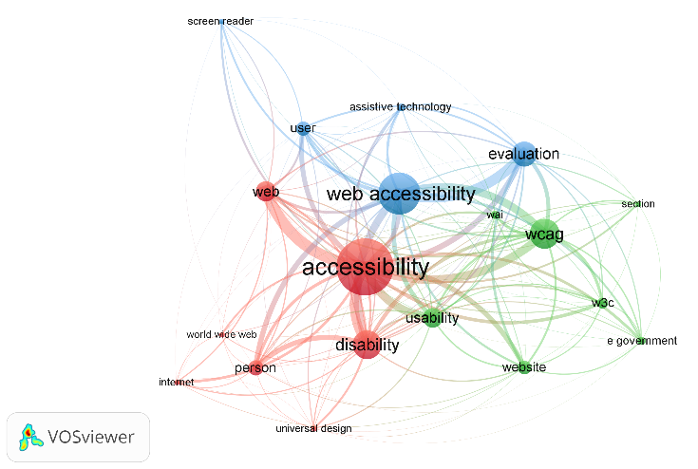
Figure 3. Network visualisation map of the author keywords

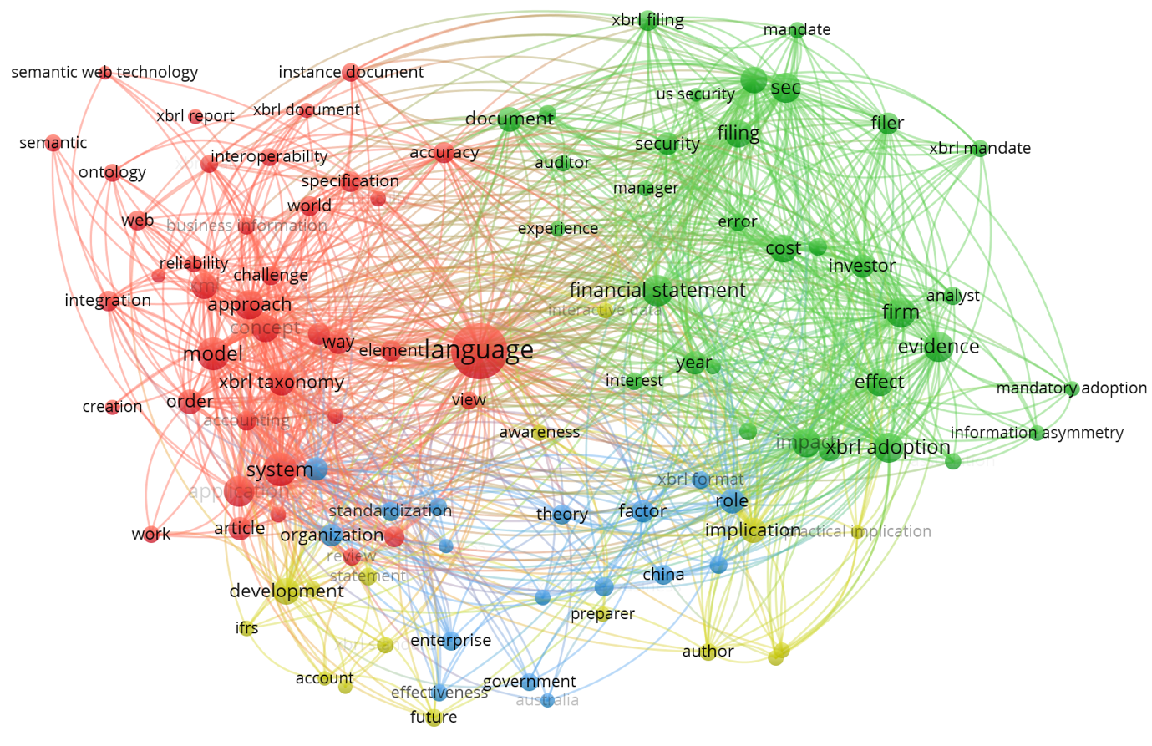

Figure 4. VOSviewer visualisation of a term co-occurrence network based on title and abstract fields (Binary Counting)

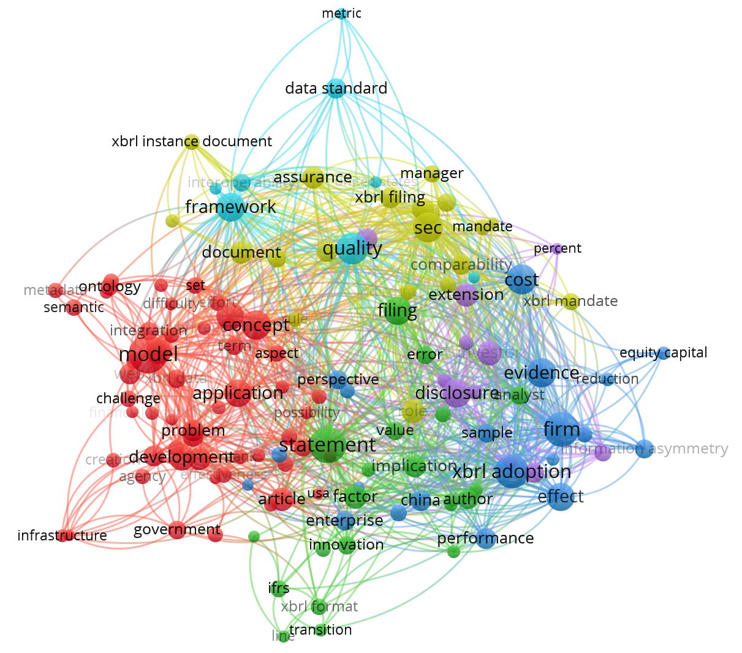
Figure 5. VOSviewer visualisation of a term co-occurrence network based on title and abstract fields (Full Counting)

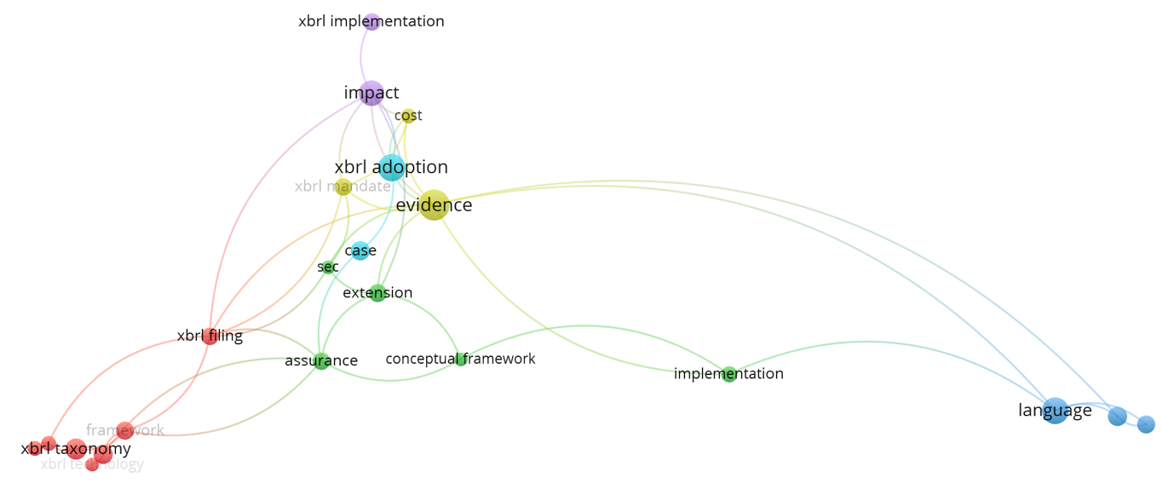

Figure 6. VOSviewer visualisation of a term co-occurrence network based on title fields (Binary Counting)

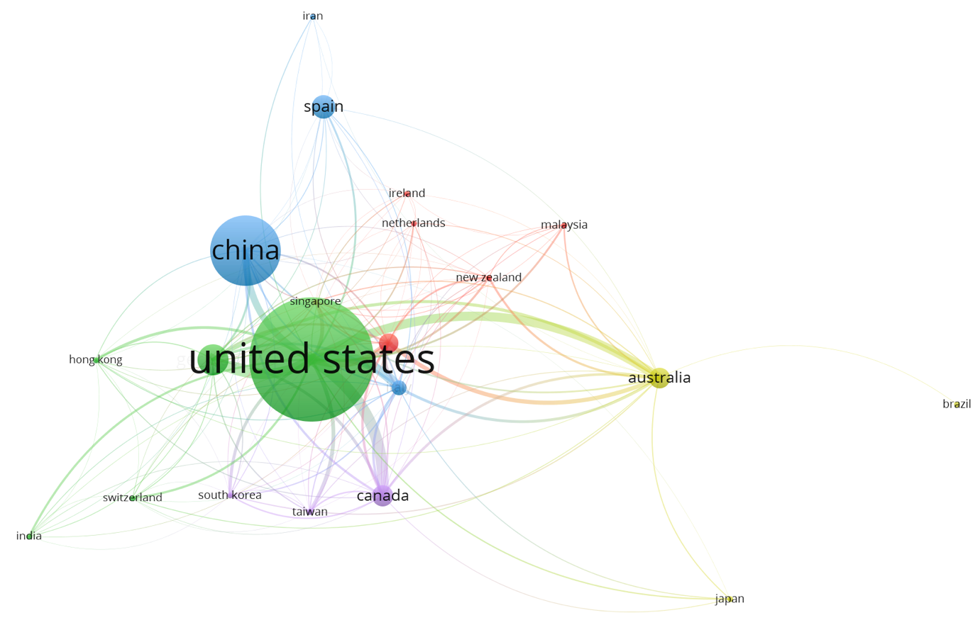

Figure 7. Network visualisation map of the citation by countries
Note: Minimum number of documents of an author = 1; Minimum number of citations of an author = 5

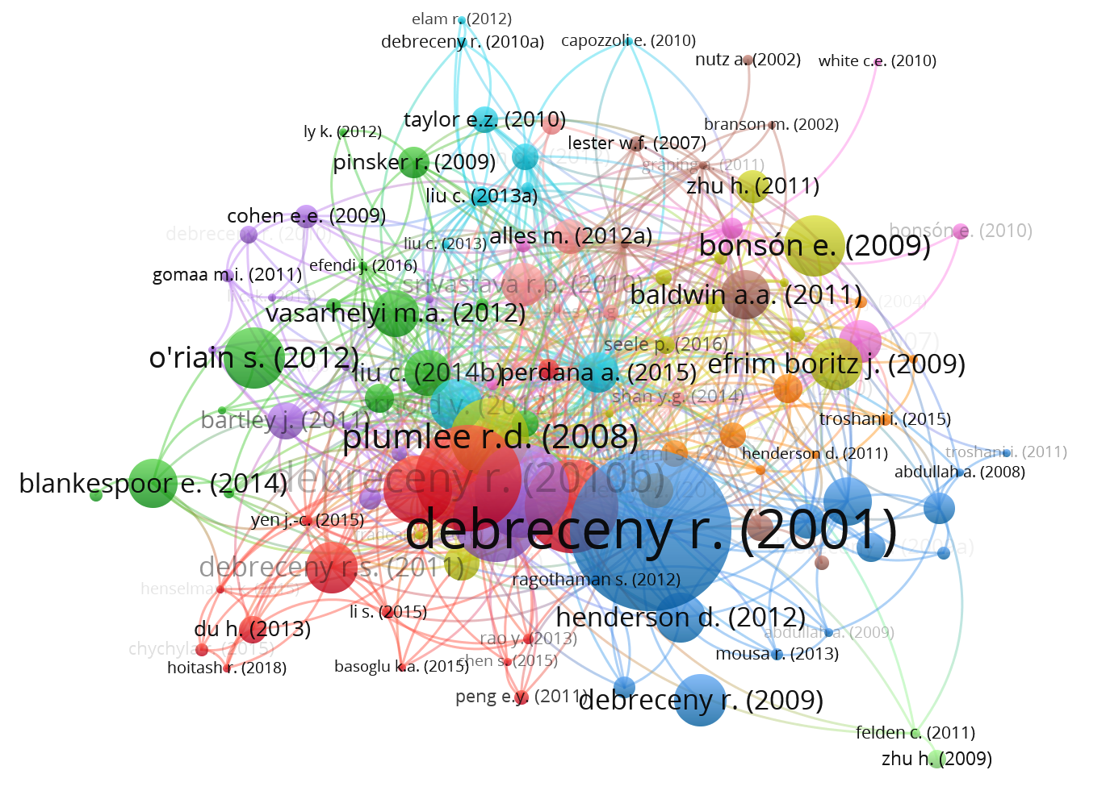
Figure 8. Network visualisation map of the citation by documents
Minimum number of citations of a document = 5

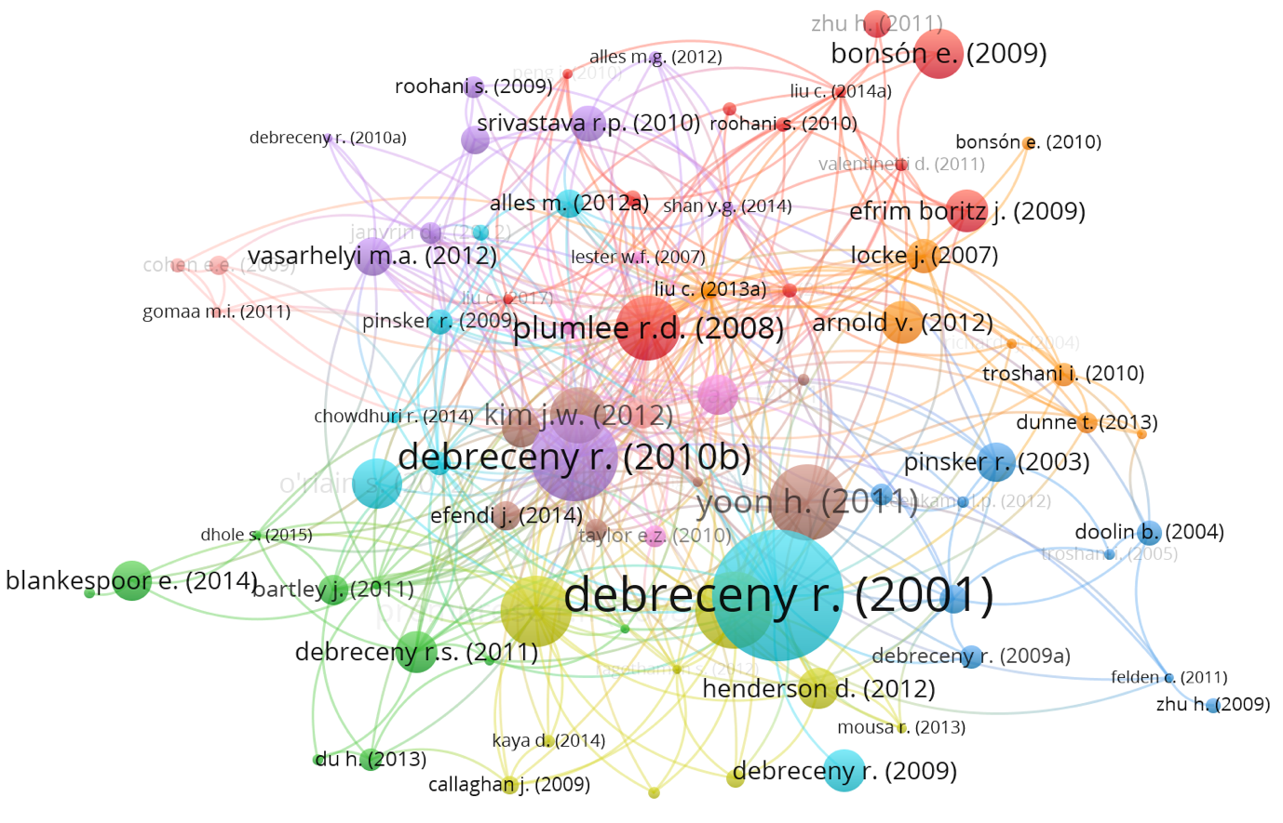
Figure 9. Network visualisation map of the citation by documents
Minimum number of citations of a document = 10

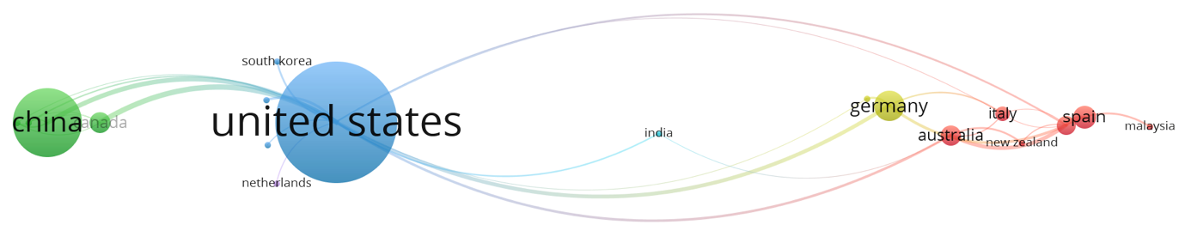
Figure 10. Network visualisation map of the co-authorship
Note: Unit of analysis = Countries; Counting method: Fractional counting; Minimum number of documents of a country = 3; Minimum number of citations of a country = 5

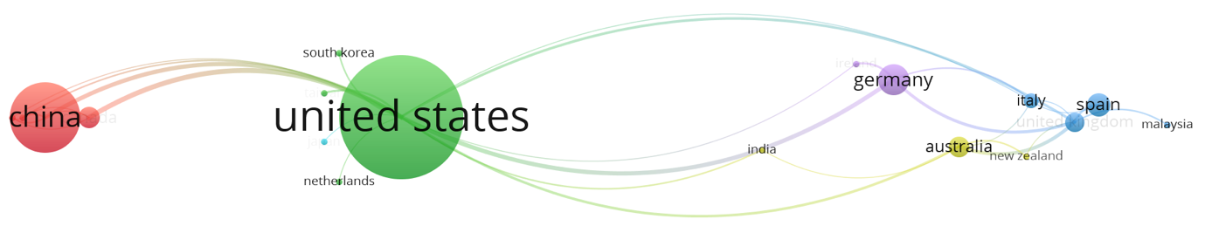
Figure 11. Network visualisation map of the co-authorship
Note: Unit of analysis = Countries; Counting method: Full counting; Minimum number of documents of a country = 3; Minimum number of citations of a country = 5

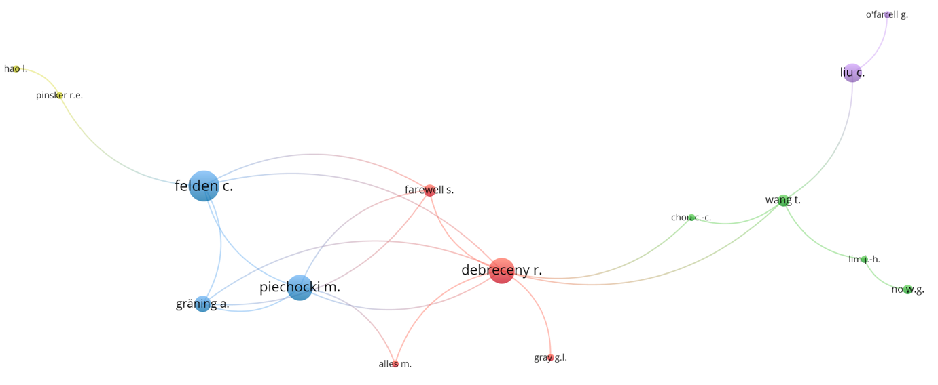
Figure 12. Network visualisation map of the co-authorship
Note: Unit of analysis = Authors; Counting method: Fractional counting; Minimum number of documents of an author = 3; Minimum number of citations of an author = 3

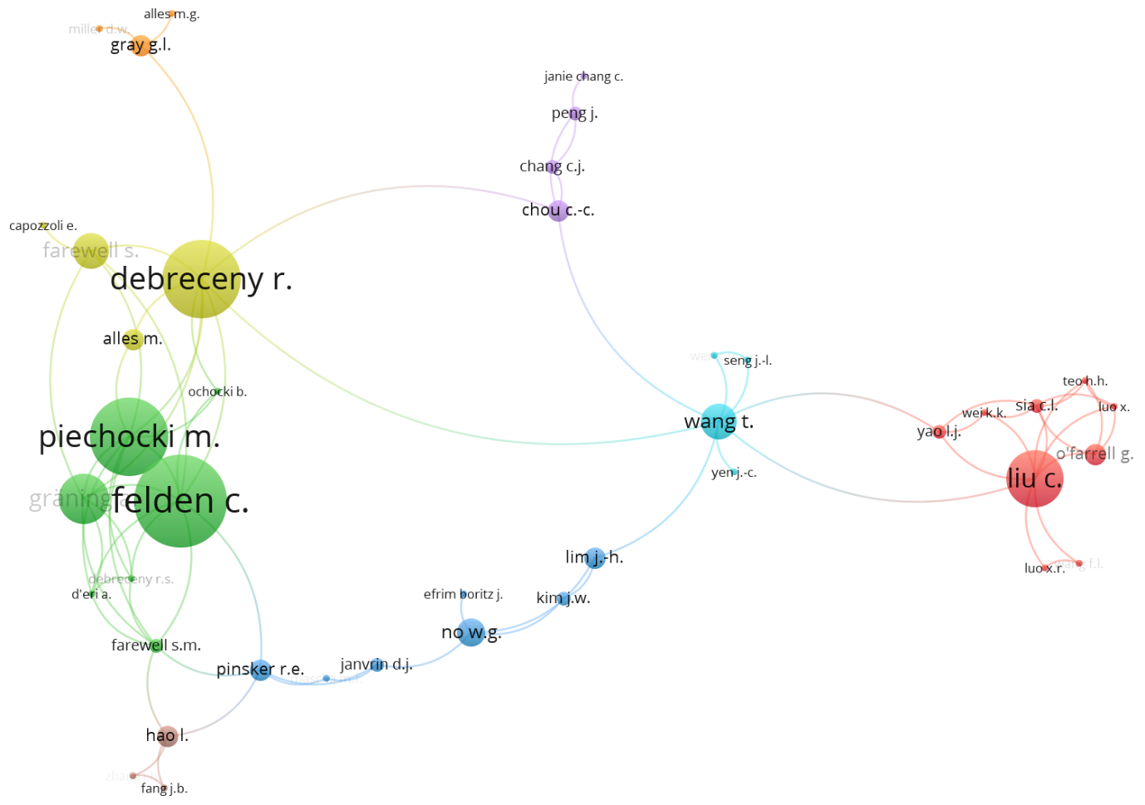
Figure 13. Network visualisation map of the co-authorship
Note: Unit of analysis = Authors; Counting method: Fractional counting; Minimum number of documents of an author = 1; Minimum number of citations of an author = 5

- DISCUSSION

RQ…

- CONCLUSION

Summary –

Contribution –

Limitation of the study –

Future research –

ACKNOWLEDGEMENT

REFERENCES

Ahmi, A., & Mohamad, R. (2019). Bibliometric analysis of global scientific literature on web accessibility. International Journal of Recent Technology and Engineering, 7(6), 250–258.
Ahmi, A., & Mohd Nasir, M. H. (2019). Examining the trend of the research on extensible business reporting language (XBRL): A bibliometric review. International Journal of Innovation, Creativity and Change, 5(2), 1145–1167.
Kushairi, N., Ahmi, A. (2021) Flipped classroom in the second decade of the Millenia: A bibliometrics analysis with Lotka’s law. Education and Information Technologies. https://doi.org/10.1007/s10639-021-10457-8
Wahid, R., Ahmi, A., & Alam, A. F. (2020). Growth and Collaboration in Massive Open Online Courses: A Bibliometric Analysis. The International Review of Research in Open and Distributed Learning, 21(4), 292-322. https://doi.org/10.19173/irrodl.v21i4.4693
Zakaria, R., Ahmi, A., Ahmad, A. H., & Othman, Z. (2020) Worldwide melatonin research: A bibliometric analysis of the published literature between 2015 and 2019, Chronobiology International. https://doi.org/10.1080/07420528.2020.1838534

